What is Node.js? An explanation too late

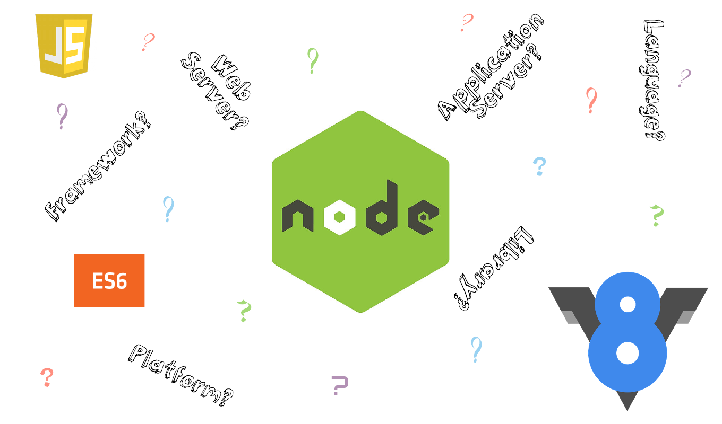
I work in an ecosystem of autobots and decepticons(i.e) one team living in the open source world while the other teams endorse typical enterprise tool based development culture. As we converge too often these days, I thought of writing this to take a deep dive into what exactly is Node.js

V8 Javascript Engine — Under the Hood:
some basics of computers consists of processors, which when given a command, executes it. But in order to talk to a processor, we need a language
No. It isn’t. Processors do not understand high level languages .so its convert V8engine in highleve l anguages to Instruction Sets(Machine Code) language converted .

There are different types of instruction sets for different types of processors. So the code we write must be converted into these instruction sets for the processor to execute. This conversion must be performed by some process and this is where Javascript engines make their entrance.

A Javascript engine is a program that converts Javascript code into instruction sets that the machine can understand. There are many JS engines created and maintained by technology leaders of the world and the most popular among them is the V8 Javascript Engine developed by Google. World’s famous browser, Google Chrome, runs on top of V8 Javascript engine.
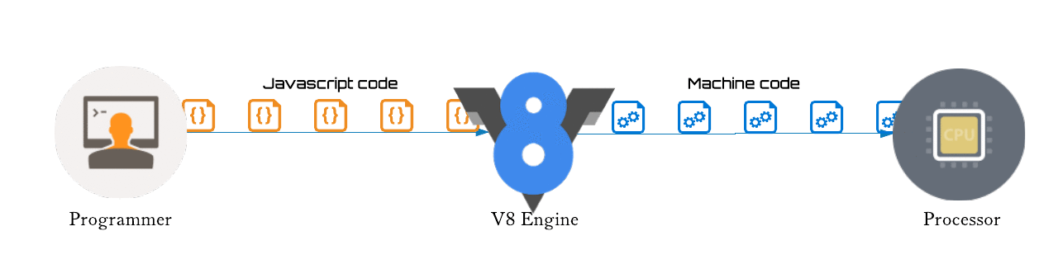

Internals of Chakra
From its inception in IE9, the Chakra JavaScript engine was designed around two guiding principles, which remain equally important in IE10:
- Minimize the amount of work on the critical path for the user experience. This involves deferring as much work as possible until absolutely necessary, avoidingwork altogether, making use of periods of inactivity, and parallelizing work to minimize impact on the responsiveness of the application.
- Take advantage of all available hardware. This translates to utilizing all available CPU cores, as well as generating advanced specialized CPU instructions, for example, Intel’s SSE2, if available.
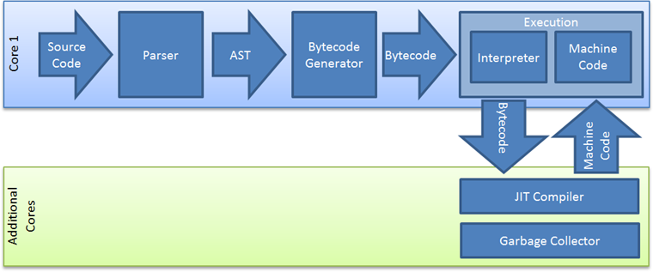
Chakra’s Parallel Architecture
Chakra, though only one of the browser subsystems – is itself comprised of several components which work together to process and execute JavaScript code. When thebrowser downloads a JavaScript file it hands its content over to Chakra’s parser to verify its syntactical correctness. This is the only operation that appliesto the entire file. Subsequent steps are performed individually on each function

